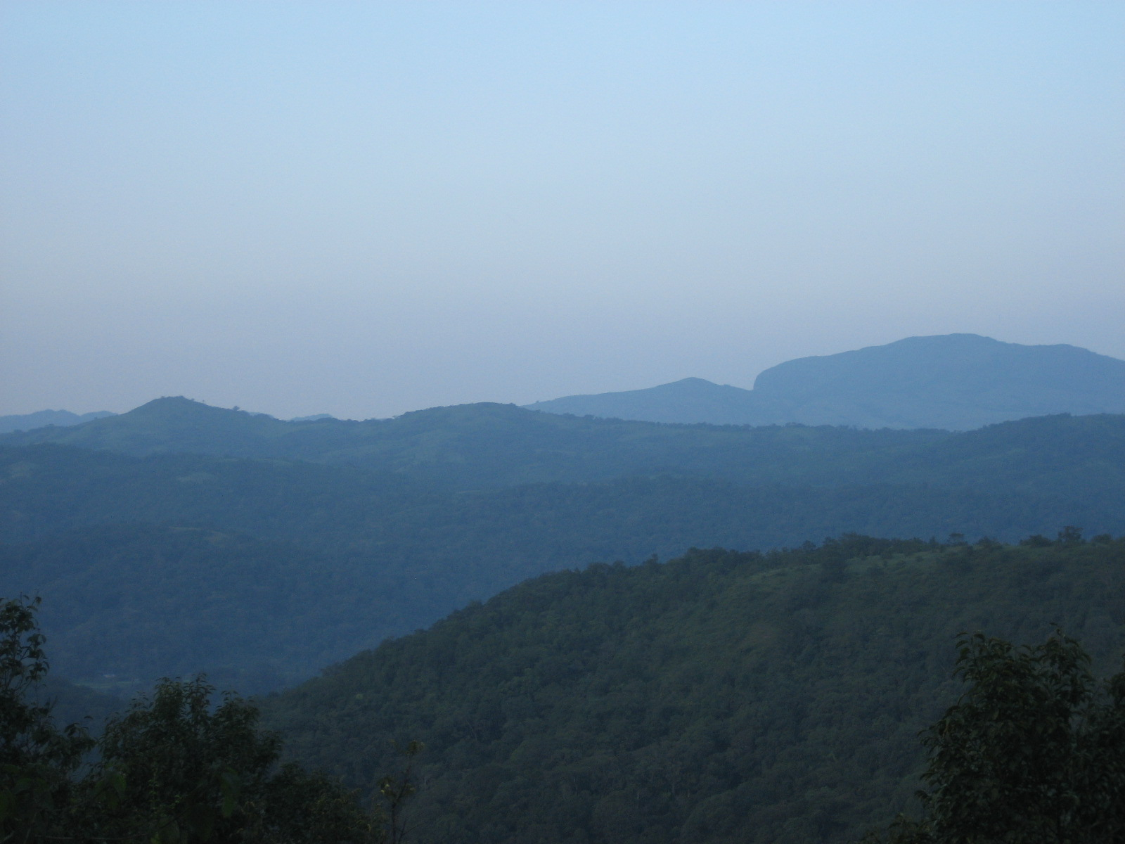
Lauren Erickson, Western Washington University
Management Internship - Rainforest Retreat, Kodagu, India

The nine-month internship I held at Rainforest Retreat was listed as a “Hospitality” internship. I would introduce myself to our guests as the “Hospitality Manager,” or “Management Intern,” or the “Junior Manager,” of the Retreat. It was difficult to explain my post quickly because it was so multi-faceted. It was truly a holistic internship and the position became more and more uniquely mine as my interests grew and were in turn fostered by Sujata, the plantation’s owner. By the end of my time there I would say, “Well, I’m technically a management intern, and I’m in charge of making sure all the guests are comfortable and coordinating your stay. I also guide treks and lead plantation tours. But I also like to work in the garden when I have the time. And I’m also helping with the research projects of the NGO. I have also created a few children’s programs. And I help in the kitchen.”
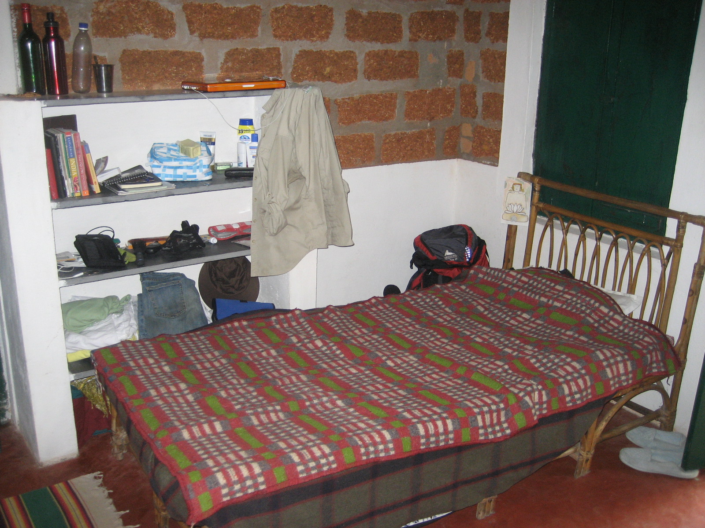
When I first arrived at Rainforest Retreat/Mojo Plantation in September, I was sure I’d made a huge mistake. My Indian roommate, Chitra, and two other American interns, all older and more highly educated than I, greeted me at my room. I felt I was in over my head. I was afraid to walk down the road in front of my cottage (which I discovered soon was actually just a driveway) for fear of being hit by one of the insane Indian drivers I’d seen on the way there. I felt alone. Everything was damp. The rains had not yet ended as promised, and would not end for another month. I woke up in the middle of the night with a sore throat from my musty pillow, damp from my blankets and went to the bathroom only to find no toilet paper by the commode. I could not erase the words beating into my mind, “WHAT THE HELL AM I DOING HERE?” And the all-consuming sentiment, “NINE MONTHS?!”
My bed in our shared room.

Before I arrived, it would have been helpful to know more about my internship site. Nobody from IE3 had interned there before. I wish IE3 could have gotten more information about the daily routines of the internship or had been able to contact a previous intern for information. I felt like I was thrown into a totally new place with almost no preparation. My orientation about “India” was about an India I barely even interacted with. I was in South India, the orientation was about North India.
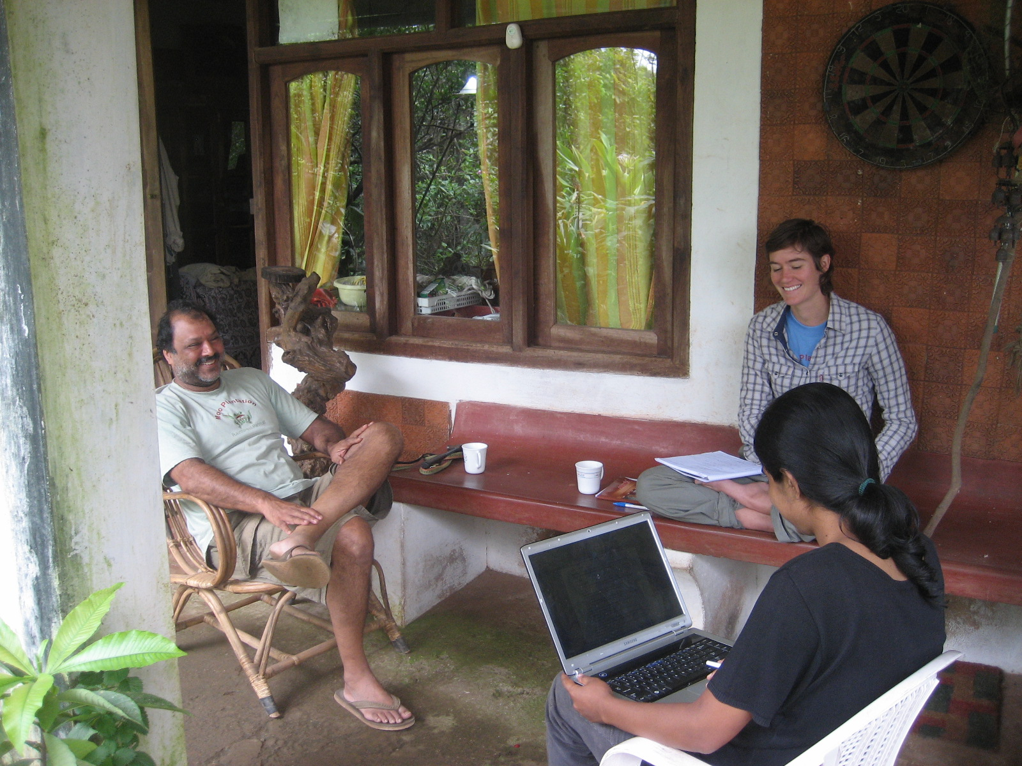
I felt insecure about my surroundings and daunted by the amount of time that lay ahead of me in this new place. I only had confidence in my ability to fulfill the duties of a straightforward management internship. I was eager to start right away. The other American interns were working on a very different project from me, and were having trouble gaining the necessary forward momentum in their research. I was glad to have many duties with which I was already comfortable. I went into the small office to set up Sujata’s laptop from which I would answer all booking emails. I felt comfortable asking her questions and spent time looking through her previous booking emails to get a feel for the information I would need to grasp in order to answer them effectively. For a while we would answer the emails together, with me composing them and sending them to Sujata for approval before sending them to the guest. Learning these procedures and learning how to schedule and confirm bookings in “The Book” in order to coordinate with the rest of the staff seemed easy enough and well-structured. Sujata had her systems already in place that would make this process simple. This made me feel secure, and gave me the sense of productivity and purpose that helped me sleep better at night. The hard stuff had yet to come.
Meeting with Anurag and other interns.
The first weekend with guests was the true measure of what I would be dealing with for the rest of the internship. All of a sudden Sujata, my safety net, disappeared. She was around her house, but not with the guests. It was up to me and the other interns to interact with and solve all the problems of every guest. That first weekend there were nearly twenty people at the Retreat, which is nearly the capacity of the cottages, and beyond the capacity of the dining area. It was pouring rain, and everyone was disappointed with the lack of rainy-day activities and umbrellas. There was no form of communication between the guest area and the office where Sujata was besides a good 5-minute walk (or 3-minute run) uphill. I ran up and down so many times, and didn’t physically sit down from the moment I woke up at 7 in the morning until 6 pm, only to go back to the guests for dinner at 8. I was exhausted, and felt terribly inadequate. I knew I had been thrown to the lions to get a sense of what I needed to know and what the job really entailed, but I felt helpless, neglected, and angry. There was no way I could have known the answer to any of the guests’ questions that weekend, and I was mad at Sujata for letting me run myself ragged.
In the end it was probably the best way to learn. We had a meeting about how the weekend could have run smoother, what resources I needed to answer questions and address complaints successfully. We divided up duties fairly. After a few weeks I felt infinitely more confident and was already getting into a groove with my daily schedule.
I took to waking up around 7 am, leisurely checking emails in the office and answering any that required immediate response and communicating guest details to the kitchen and housekeeping before breakfast at 8:30. I ate breakfast with the guests and outlined the day’s activities. Usually there was a trek after breakfast, which returned before lunch, and a plantation tour after tea was served at 4 in the afternoon. New guests arrived around lunchtime and throughout the afternoon.
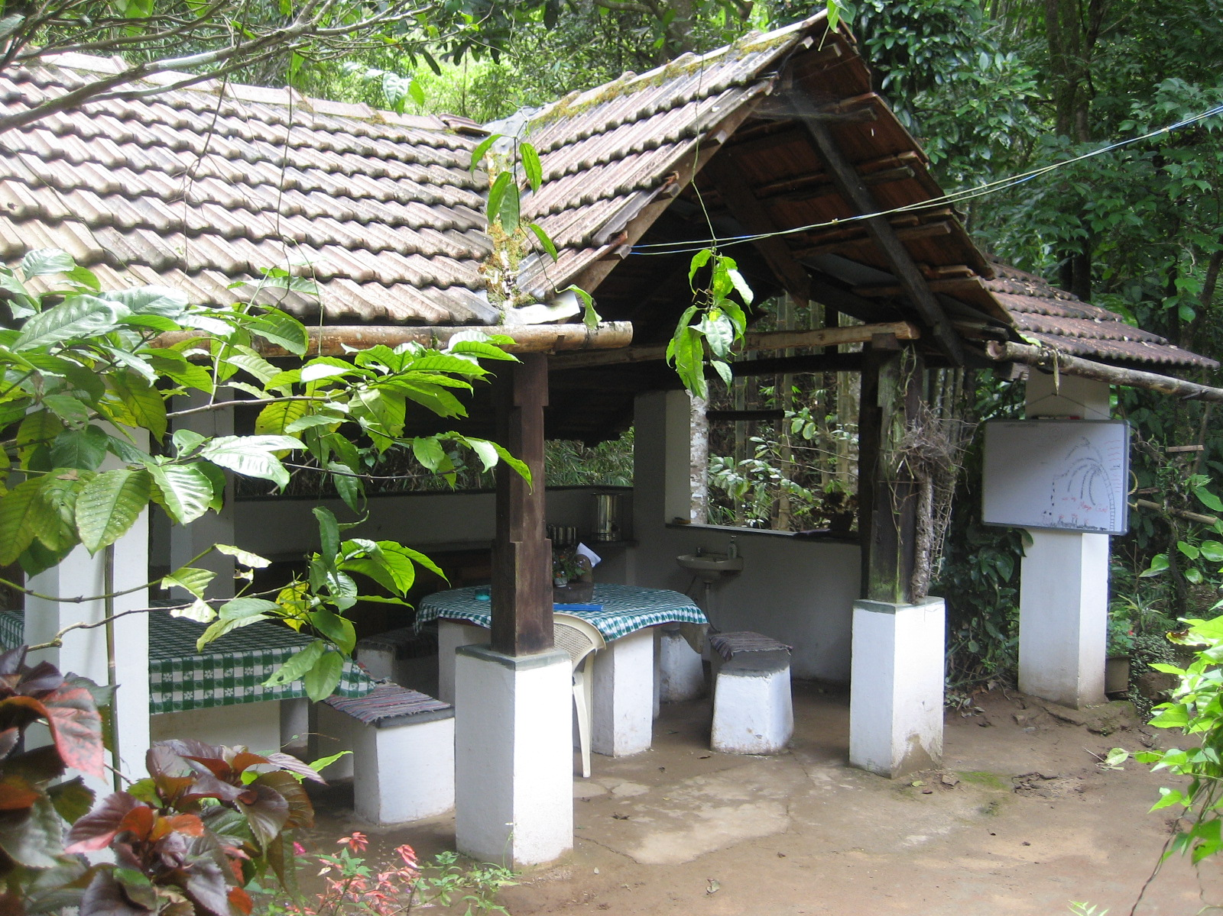
Many, many guests came through Rainforest Retreat during my time there. Often they shared with me their experiences of travel and time spent in India. I noticed patterns and common stories, which for me meant having the same conversation multiple times.
Dining area for guests (and me).
“And what on earth does that head bob mean, anyway?” Was a common conversation-starter. I must have had this conversation at least twenty times.
More fascinating to me than speaking to other traveling Europeans about the oddities of Indian culture, was speaking to resident Indians about Indian culture. One of their favorite topics was language. With 1600 languages and thousands of dialects, language, like food, is something each region takes individual pride in. In Karnataka, the language is Kannada. In Kodagu, the dialect is Coorgese. While traveling in India, these languages become obsolete, but in our small, isolated world, Kannada was what nearly everyone spoke. What I experienced in my travels was that the common language that every region shares is not Hindi as I expected, but English. For me this posed a problem in my effort to learn Kannada. I would ask the bus ticket salesman, “Eshtu?” How much is the ticket? He wouldn’t understand my accent so I would ask in English, “How much?” And he would respond in English. So my efforts to learn the language were immediately stunted. When a Kannada-speaker heard me say one of the few words I memorized, he would be surprised and pleased, but would then address me in English. There was little actual immersion in the language. For the first few months I couldn’t even tell if the people around me were speaking Kannada, Tulu, Tamil, Malayalam, or Hindi. If I listened for words in conversation, I wouldn’t know what language I was picking up.
The few words I did learn were those that were useful in travels around Madikeri and the rest of Karnataka. The became obsolete as soon as I crossed a border.
Namaskara - Formal greeting.
Namaste - Less formal greeting. Still appropriate for strangers not of a higher station than yourself.
Oota Aita? - (Pronounced “Eye-tah”) Literally means, “Have you eaten lunch/dinner?” (Used as a greeting for people with whom you are familiar) Nasta Aita? is used in the morning, for breakfast.
Eshtu - How much (works in matters of money, distance, any quantitative question)
Ondu, Eredu - One, two (good for ordering in restaurants)
Inondu - One more.
There is no word in Kannada that means “Thank you.” Just say “Thanks.”
Quirks like this played a huge role in my understanding of Indian culture. Why is there no word for Thank You? Because in small communities where everyone is considered family, helping someone in a small way is not considered a favor, it is simply expected, and not worthy of gratitude. It would have been unforgivable for your brother’s wife not to serve you food. So when she does, one simply bobs one’s head, or does nothing. Indians told me they think we say it too much, and that it seems unnecessary. When I first arrived in India I thought, “Well, it’s different, but not as different as everyone said it would be.” I soon learned that the differences lie beneath the surface. They lie in interactions, and language, and tradition. I realized that most of the time it was futile to ask, “Why?” Because whomever you’re asking will just shrug, as if to say, “Why is the sky blue?”

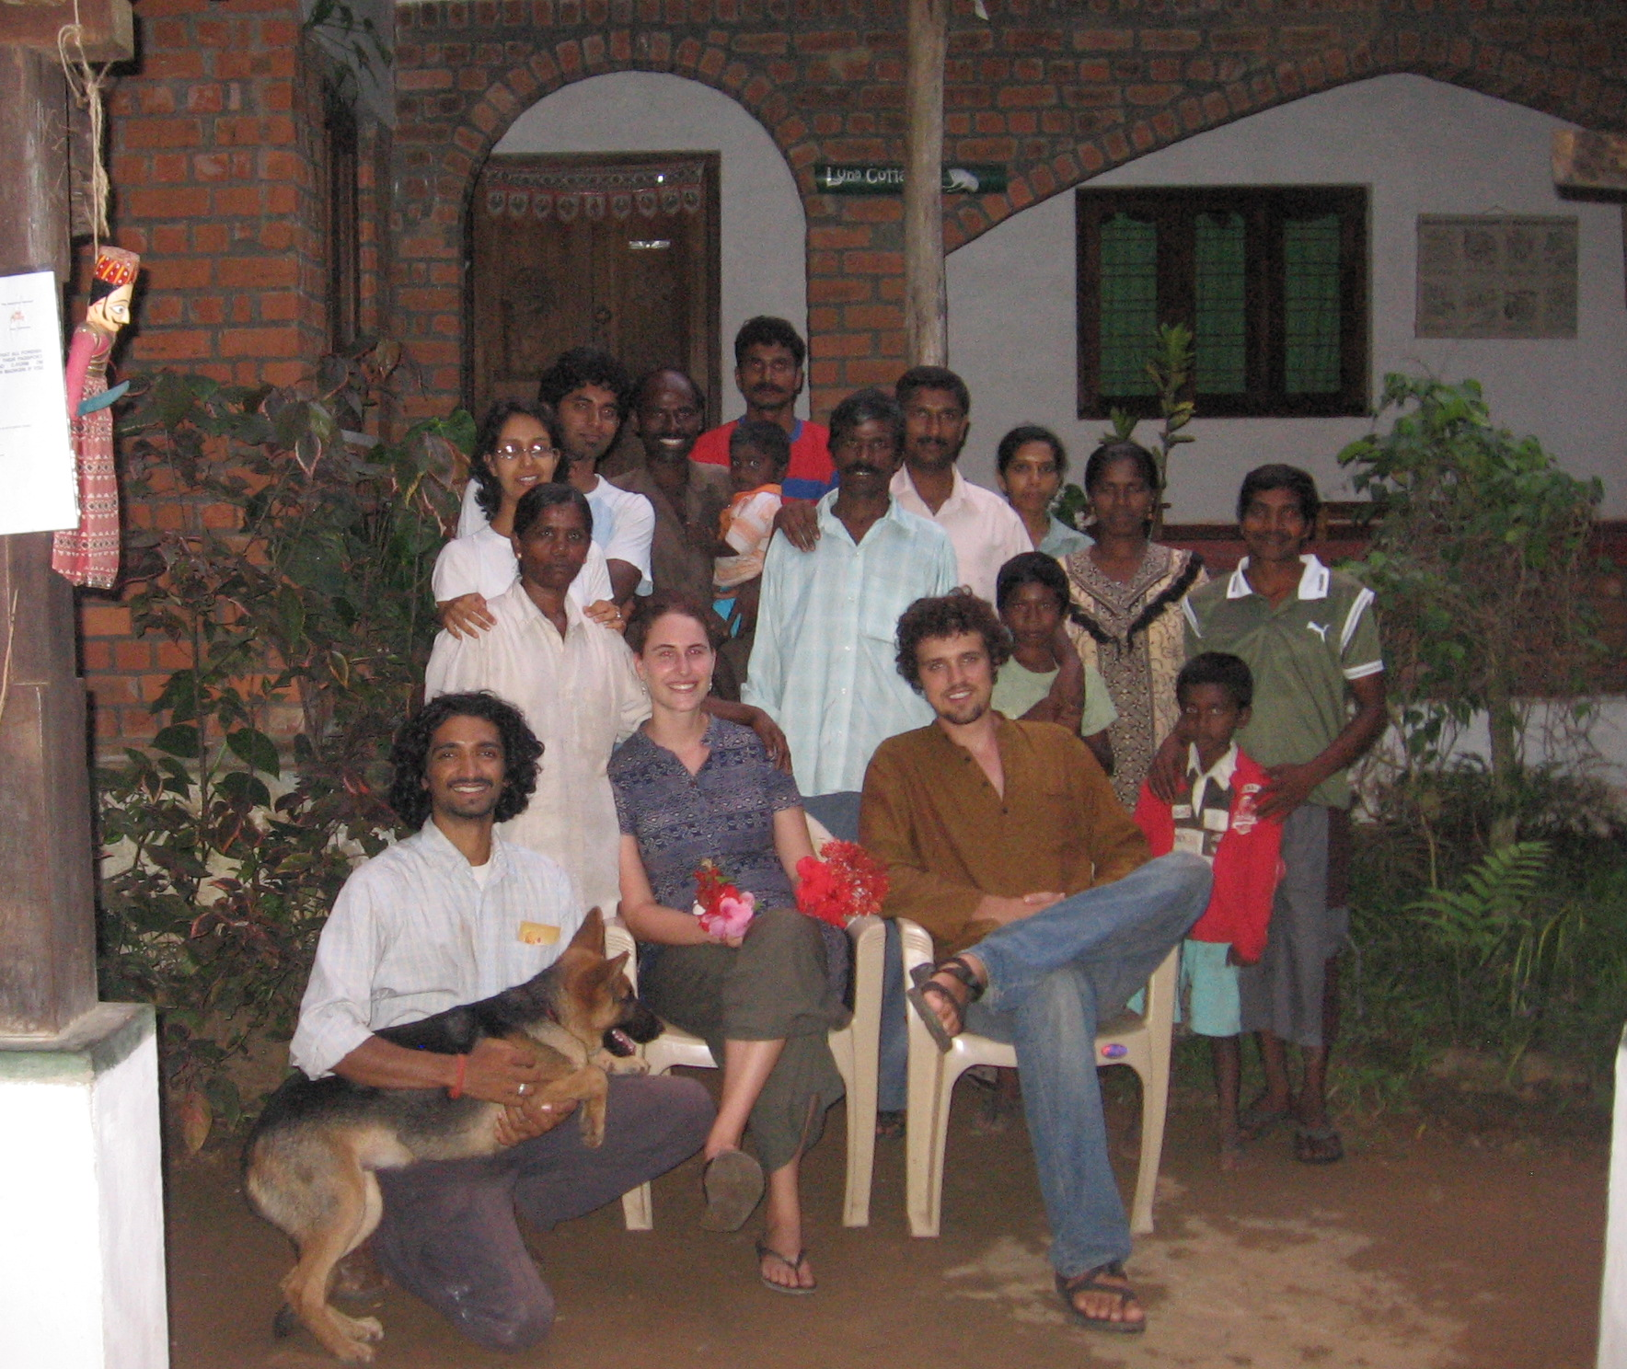
When I try to relate the details of my time in India, I often find people asking me, “So what was good about your experience?” It makes me sad to hear that, because so many good things came of it. But they’re difficult to describe. The hard times, the loneliness, the challenges and disappointments, all seem more story-worthy than the positive. Personally, what I gained from my internship site, was a deep connection to the families that made the Retreat and Plantation breathe. My dear friends on the plantation don’t seem to fit into a story. Most of the women on the plantation didn’t speak a word of English. Our language was physical: smiles, gestures, laughter. I learned how to cook. I learned how to grow things. I learned how to learn by interacting with all the life forms around me. I learned to trust myself.
Friends at Rainforest Retreat.
Professionally, the benefits are myriad. For the first time I had to keep a records of the guest house’s expenses. Having a deep aversion to all matters of money, this was by far the most stressful of my duties. But by the end of the internship, I felt comfortable and competent. I can now write professional emails, budget my time effectively, communicate, speak to an international audience, and manage a large staff. I can also learn from my mistakes without beating myself up about them, and have realized how important it is to have a “system” and stick to it.
I made myself an asset to the organization by going beyond my ascribed duties to learn about organic farming techniques, developing children’s programs, leading school groups and helping with research projects. I took responsibility for my mistakes and did my best to correct them in the future. I am proud that I maintained a professional level of friendship with all of the staff and made the most out of my relationship with Sujata, my mentor.

Tips for the next intern:
- Take the guests’ needs and complaints to heart professionally, not personally. You will spend nearly all your time with the guests, and they may not always be friendly and nice. Act professionally and they will treat you with more respect.
- If Sujata lists 100 things for you to do in one day, don’t feel obligated to do them all. Use your judgment.
- Spend time getting to know the staff, they are your best resource for keeping your head above water.
- Spend time in the field, get to know the plants, listen to Sujata and read lots of books. Get interested. Love soil.
- If you feel you don’t have time for yourself, MAKE time for yourself.

